VISUAL ART LESSON: MONDRIAN MAPS | 2 X 45 min lessons
Unit: COMMUNITY / MAPS | Year Levels: Foundation (Prep) | Victorian Curriculum Levels: F
Achievement Standard Level F– Visual Arts
By the end of Foundation
- Students make artworks using different materials and techniques that express their ideas, observations and imagination. (1)
- Students identify and describe the subject matter and ideas in artworks they make and view. (2)
Lesson Content –
Students will explore Mondrian artworks that can be used as inspiration for maps, to show where we live, represent the streets around our houses and places we belong to or go to in the community. Students will learn about the Primary Colours, the basic Colour Wheel and Lines that are horizontal and vertical.

Elements of Art: | Art Vocabulary: | Principles of Art:
Line Tone Texture Colour Form Shape Space | Primary colours Colour Wheel  horizontal vertical long short | Balance Harmony Contrast Rhythm Pattern Tension

Focus Artworks:
Piet Mondrian:
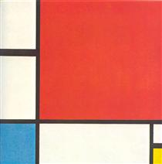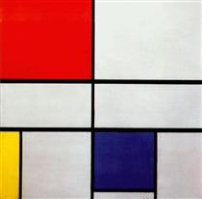
Composition with Red Yellow Blue 1930 Composition C (No. III) with red Yellow and Blue 1935

Learning Intention & Success Criteria | Teaching & Learning Activities | Resources and Materials
Lesson 1:  To learn about the artist Piet Mondrian and some of his artworks.  I can describe some of Mondrian’s artworks, identifying the colours (primary colours) and horizontal and vertical lines.  To make a Mondrian style collage.  I can glue down black strips horizontally and vertically.  I can choose varied sized squares and rectangles using all the primary colours at least once and glue them down touching the black lines.  I can add black strips on the other edges of the coloured shapes | ENGAGE:  Intro Mondrian artworks- View compositions with primary colours (red, blue, yellow) and black lines.  What types of shapes, colours and lines do you see?  I See / I think / I wonder  Discuss it’s likeness to a map – the lines are like streets and the shapes are houses or buildings.  Talk about the lines and what direction they are going. What colours are used? Why aren’t all the squares filled?  Teaching point- Prep students, early in the year will just be learning about the primary colours and horizontal and vertical lines.  View a basic colour wheel with primary and secondary colours. See what students know about how the colours are made.  Watch video- a song about colours with emphasizes the primary colours.  Play a game with primary colours in the art room- for example- move around and then give one of the primary colours they need to touch.  Discuss what would make our art work look like Mondrian:  needs horizontal and vertical lines  needs to have rectangles and squares  can only use red, yellow, and blue and  leave white for contrast  Students use some pre-cut long black strips to glue down in horizontal & vertical lines on white A3 paper (at least 2-3 each direction.  Glue down primary coloured shapes into the corners of some of the black strips. Could talk about ‘balance’ and not having all the colours in one area or on one side- to spread them around and leave some areas white.  Add more black strips to section off the colours- these lines could be short or may cross over other lines- they can be trimmed to fit.  When complete ask students to point to given colours or lines on their piece to review the art vocabulary.  Students share their artworks with each other, describing the colours and line types.  Glue onto black cover paper for display in the art room or near the students classroom. | Images of Mondrian artworks:  https://www.wikiart.org/en/piet-mondrian/all-works#!#filterName:all-paintings-chronologically,resultType:masonry  Image of a basic colour wheel  Youtube video: Primary Colours:  https://www.youtube.com/watch?v=v9gIj0j7Ba0  Pre- cut black strips 1cm wide  Pre-cut squares and rectangles in the primary colours- various sizes  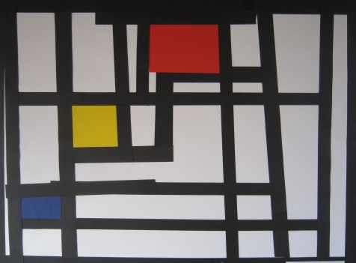 | Explore & Express  Explore ideas, experiences, observations and imagination to create visual artworks (VCAVAE017)  - By viewing a range of artworks with a common theme or subject matter, and make their own interpretations based on their experiences, observations and/or imagination  - By identifying and using visual conventions in their artworks after investigating different art, craft and design styles from other cultures  and times.  Visual Arts Practices  Experiment with different materials and techniques to make artworks  (VCAVAV018)  - By exploring a range of materials and technologies to visually express their experiences, for example, paint, pencils, ink and photography  Present & Perform  Create and display artworks  (VCAVAP019)  - By displaying and discussing a series of artworks created by their class  Respond & Interpret  Respond to visual artworks and consider where and why people make visual artworks  (VCAVAR020)  - By identifying the subject matter of a series of artworks based on the same theme  - By identifying how design elements, such as line, shape, colour or texture, are used in their artworks and in the artworks of others

